If you are given two traversal sequences, can you construct the binary tree?

Our aim is to determine for how many and which given traversal sequences, we can predict a unique tree.

Claim 1: Given an inorder traversal with n nodes, one can produce 2n-1 trees.

Claim 2: Each of the trees have a unique preorder traversal (This uniqueness also holds for postorder and levelorder traversal)

Proof by induction: T(n)=number of ways to produce trees with a given inorder traversal.

Base Case: n=1, T(1)=21-1 = 1.

Induction Hypothesis: Suppose our claim holds true for all n<k.

If n=k,

Without loss of generality, we can assume inorder traversal as 1,2,3,...,k-1,k. To produce trees with above inorder traversal, we must produce a tree with inorder traversal 1,2,3,...,k-2,k-1 and add node with data k at the following 2 positions:

i. Node with data k as root and rest of the tree as its left child

ii. Node with data k as right child of the last element visited during inorder traversal.

T(k) = T(k-1) + T(k-1) = 2\*T(k-1), with base case T(1)=1

Solving, T(k)=2k-1

Example:

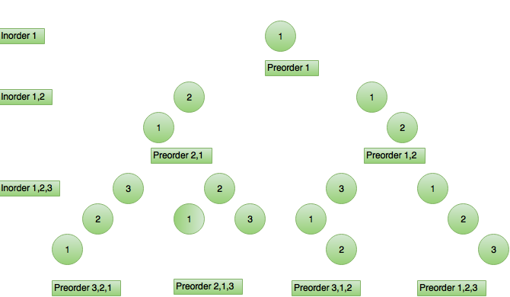

Also, 2 children of the same parent must have different preorder traversal since

i. preorder traversal of one child is formed by adding new element in the beginning of the parent's preorder sequence.

ii. preorder traversal of other child is formed by adding new element in the end of the parent's preorder sequence.

Also, 2 nodes at the same level without same parents have different preorder traversal since they must have ancestors with a common parent. These nodes have different preorder traversal by our above conclusion and adding new elements in the beginning or end can never make their preorder same.

Thus, we conclude:

1. We can determine a unique tree given

a. Inorder and preorder

b. Inorder and postorder

c. Inorder and level-order

Note: A tree might not exist when any two are given.

Ex: Inorder = 1,2,3 Postorder = 2,3,1

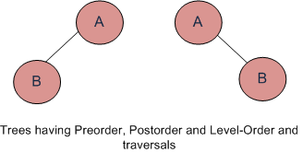

2. We cannot determine a unique tree given

Postorder and Preorder  
Preorder and Level-order  
Postorder and Level-order

For example, Preorder, Level-order and Postorder traversals are same for the trees given in above diagram.

Preorder Traversal = AB

Postorder Traversal = BA

Level-Order Traversal = AB

So, even if three of them (Pre, Post and Level) are given, the tree can not be constructed.